Task description

You are a data analyst working for a company planning to venture   into a new market involving financial services. In line with this,   it is requesting insights on sources of financing companies tap   into when entering the said industry. Decision-makers will use insights from your report   for their alternatives analysis as they explore probable   sources of financing to start offering the new service.

Task 1

Prepare the dataset for the analysis by creating a new table selecting the records where the market is financial services. Keep in mind that the values in this column are misspelled.

SQL code:

create table investment2 ( market varchar (50),

funding_total_usd numeric,

status varchar (20),

country_code varchar (10),

founded_year numeric,

seed numeric,

venture numeric,

equity_crowdfunding numeric,

undisclosed numeric,

convertible_note numeric,

debt_fincing numeric,

private_equity numeric

)

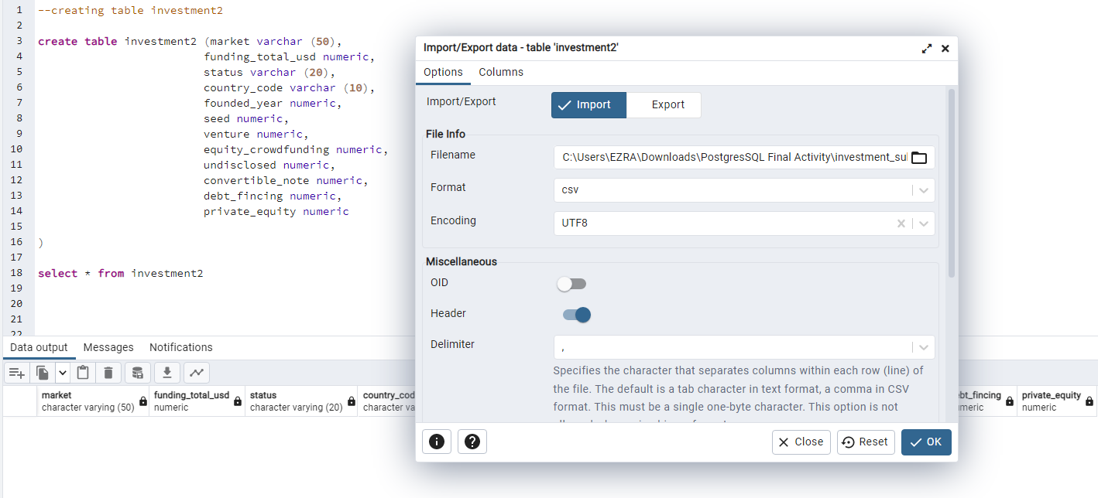

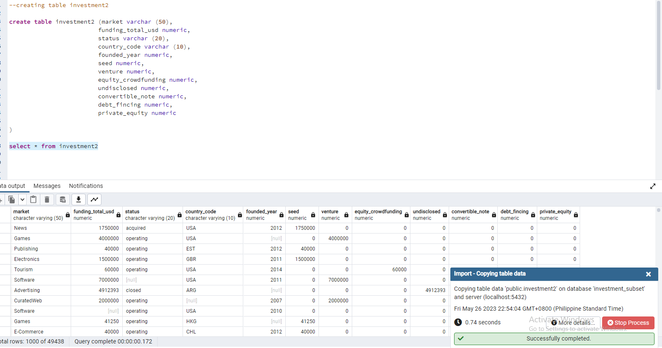

select * from investment2

where market like '%Service%'

select * from investment2

where market = 'FincialServices'

create table new_market as select * from investment2

where market = 'FincialServices'

select * from new_market

--update spelling

update new_market

set market = 'Financial Services'

where market = 'FincialServices'

--handling duplicate from the table

select funding_total_usd,status,country_code,founded_year,seed,venture,equity_crowdfunding,undisclosed,convertible_note,debt_fincing,private_equity from new_market

group by 1,2,3,4,5,6,7,8,9,10,11

having count(*)>1

select * from new_market

where funding_total_usd= 150000 and status='operating' and country_code = 'USA' and founded_year = 2013 and seed = 150000

delete from new_market

where funding_total_usd= 150000 and status='operating' and country_code = 'USA' and founded_year = 2013 and seed = 150000

insert into new_market(market,funding_total_usd,status,country_code,founded_year,seed,venture,equity_crowdfunding,undisclosed,convertible_note,debt_fincing,private_equity)

values ('Financial Services',150000,'operating','USA',2013,150000,0,0,0,0,0,0)

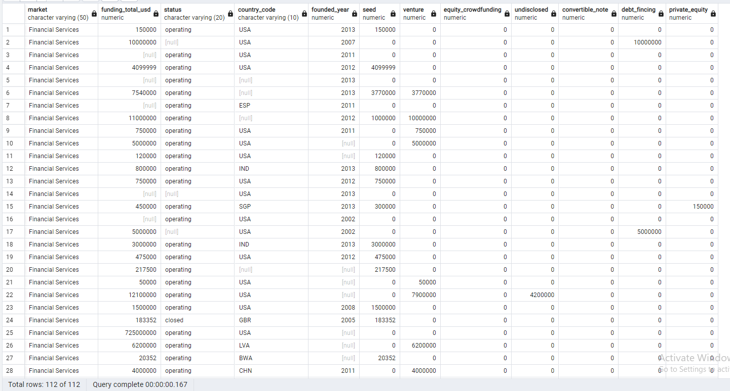

Task 2

Provide descriptive analytics that presents the number of observations of companies operating in financial services and their average, minimum, and maximum seed funding.

SQL code:

--Observations of companies operating in financial services.

select count(status) as operating_companies_count from new_market

where status = 'operating'

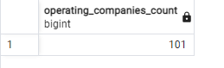

average, minimum, and maximum seed funding.

select round(avg(seed),2) as average_seed from new_market;

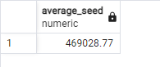

select min(seed)as minimum_seed from new_market;

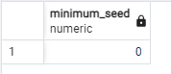

select max(seed) as maximum_seed from new_market;

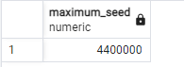

Task 3

Aware of the reality that equity crowdfunding is a bit rare in financial services, determine whether or not there has been a previous instance where a startup offering financial services received equity crowdfunding. If there was, provide details of the company, such as the country it operates in, the year it was founded, its status (whether or not it is still operating), and the amount of equity crowdfunding it acquired.

SQL code:

select * from new_market

where equity_crowdfunding <> 0;



Task 4

Determine whether or not a significant outlier in terms of total funding (USD) exists among companies that offer financial services. An outlier is an extremely high or low value. Provide details about this outlier, such as its country, status, year founded, and total funding (USD).

SQL code:

Creating zscore

select funding_total_usd,venture,equity_crowdfunding,undisclosed,convertible_note,debt_fincing,private_equity,

(funding_total_usd-avg(funding_total_usd) over ()) /

stddev (funding_total_usd)over() as zscore from new_market

zscore

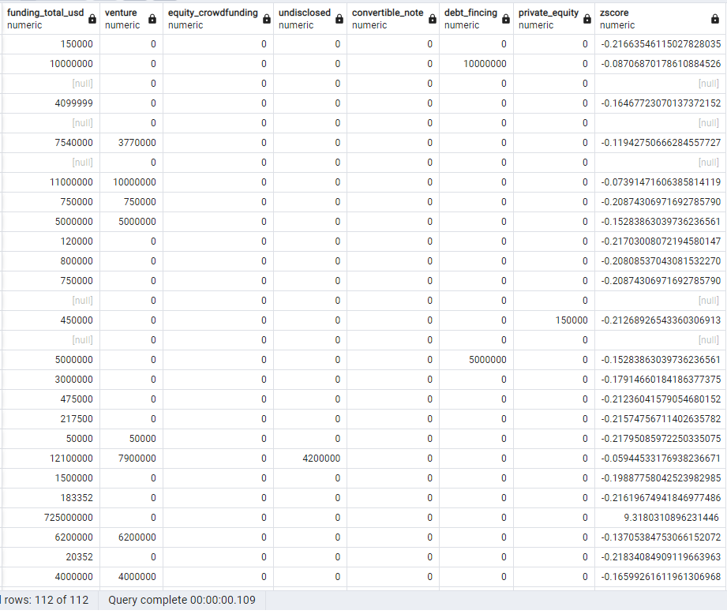

Determining outlier using zscore

Select * from (select funding_total_usd,venture,equity_crowdfunding,undisclosed,convertible_note,debt_fincing,private_equity, (funding_total_usd-avg(funding_total_usd) over ()) /stddev (funding_total_usd)over() as zscore from new_market ) as outlier

where zscore > 2.576 or zscore <-2.576

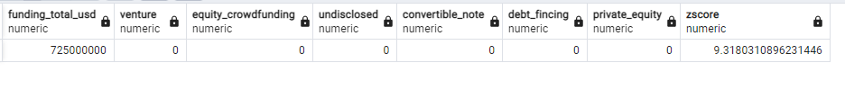

Excluding the significant outlier, provide insights on the company regarding the usual financing sources for businesses that offer financial services. Export your data from SQL to MS Excel, and create a data visualization that presents the average funds acquired from financing sources such as equity crowd-sourcing, undisclosed sources, convertible notes, debt financing, and private equity.

SQL code:

delete from new_market

where funding_total_usd = 725000000

